S | A deliberately vulnerable lab machine for practicing web app exploits, privilege escalation, and post-exploitation to gain user and root access.
Target IP | 192.168.0.114
Vulnerability Name | • SQL Injection (SQLi)  • Local File Inclusion (LFI)  • Weak Passwords / Poor Credential Management  • Misconfigured Sudo Permissions (Privilege Escalation)
Port / Service | TCP 80 / http
Severity | High 8.1
Attack Vetor | CVSS:3.0/AV:L/AC:H/PR:N/UI:N/S:C/C:H/I:H/A:H
Proof of Concept (PoC) | STEP 1 – Nmap to find the IP of the target machine.  STEP 2 – Nmap Scan to discover open ports and Services  # nmap –p- -sC –sV $ip –open  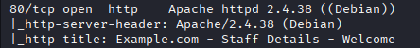  STEP 3 - SQLi is possible in search field  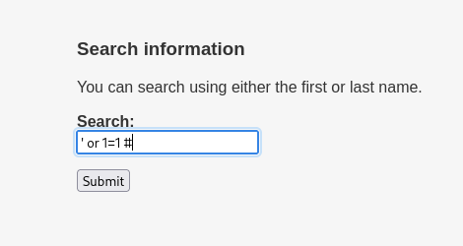  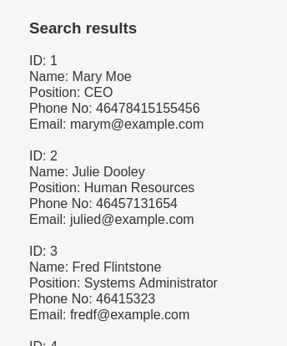  STEP 4 – Capture the request using burpsuite  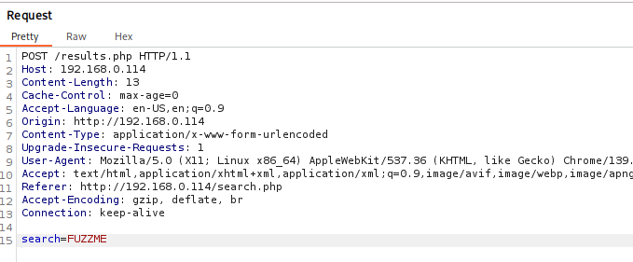  STEP 5 - Created a file with this request  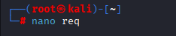  STEP 6 - By running this we found : Table names i.e.  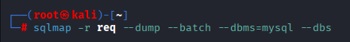  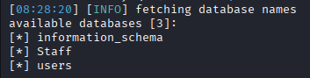  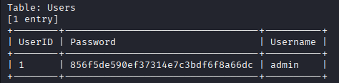  STEP 7 – found potential users password  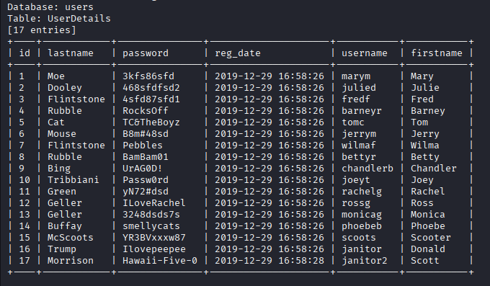  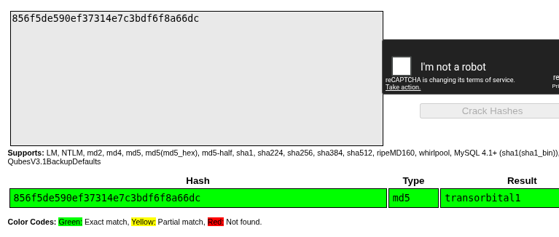  STEP 8 - Cracked Admin hash  STEP 9 - Logged in as admin  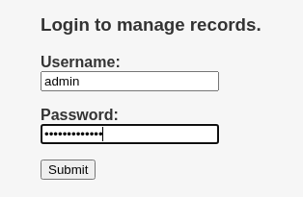  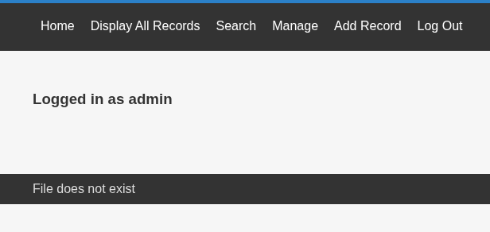  STEP 10 – Exported the URL  # export url=http://192.168.0.114/welcome.php?FUZZ=../../../../../../etc/passwd  STEP 11 - Session id is included as it is a authenticated Scan  #  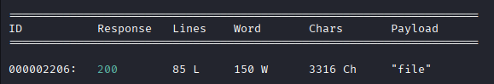  wfuzz -c -z file,/usr/share/seclists/Discovery/Web-Content/burp-parameter-names.txt -hc 404,302 -hh 963 -b "PHPSESSID=3rnefafv72e28gcec3g7q560aa" "Surl"  STEP 12 - We have local file inclusion  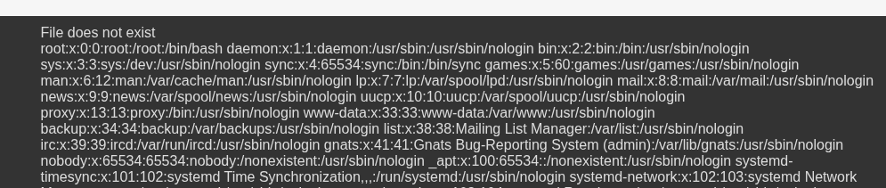  NOTE-Check if the port is open or filtered, if filtered them continue, if open go to  Step -18  Step 13 – The ssh is filtered, we cannot access it directly  #nmap –p22 $ip  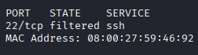  Step 14 –  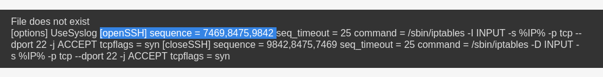  #http://192.168.0.114/welcome.php?file=../../../../../../knockd.conf  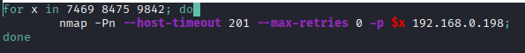  Step 15 – Created a script and the sequence in it and gave it executable permissions  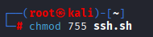  Step 16 – Execute the script  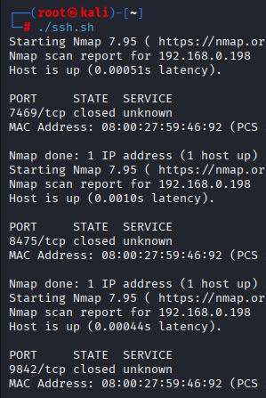  Step 17 – Now the Port is open  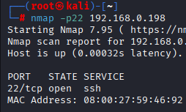  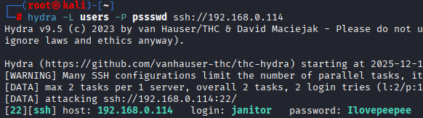  STEP 18 - Found a Working password  STEP 19 – We are In !  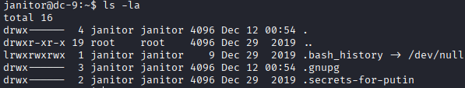  Step 20 – Found some passwords and added them in file  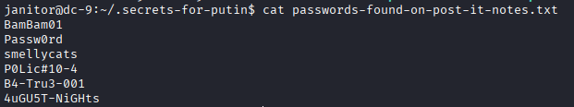  Step 21 – Found another user’s password  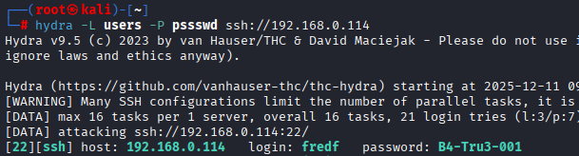  Step 22 - As fredf we can run a test file as sudo  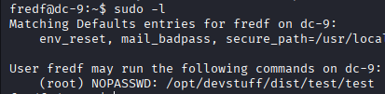  Step 23 – We can use this file to append the /etc/passwd file  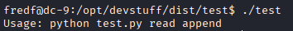  Step 24 – created a file with username and passwd  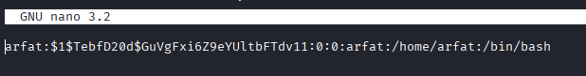  Step 25 – Ran the file as sudo and appended the /etc/passwd file  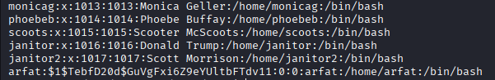  Step 26 – Switch use to arfat and we have ROOT  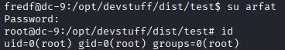  PROOF:  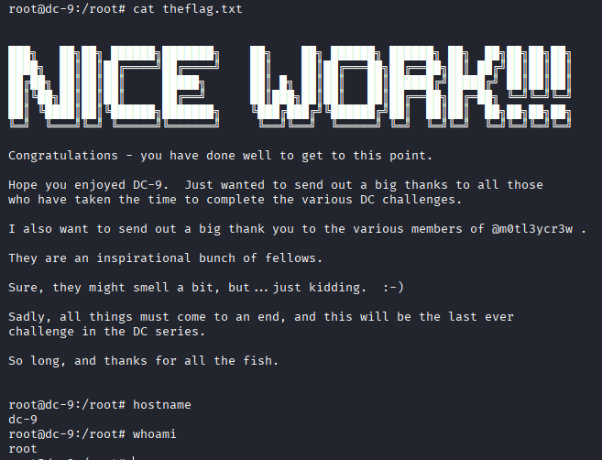
Remediation | • Use prepared statements to block SQL injection.  • Validate & sanitize all user inputs.  • Implement allow-list for file paths to prevent LFI.  • Remove unnecessary sudo permissions.  • Enforce strong password policy (complex passwords).  • Hash passwords using bcrypt/argon2.  • Keep server and web app updated.  • Restrict file system permissions.
Impact | • Full database exposure and data theft.  • Ability to read sensitive system files.  • Admin account compromise.  • Attackers gaining full ROOT access.  • Complete system takeover.  • Website defacement or malware upload.  • Loss of integrity, confidentiality, and availability.
References | https://owasp.org/www-community/attacks/SQL_Injection  https://owasp.org/www-community/vulnerabilities/Local_File_Inclusion  https://owasp.org/Top10/2021/A07_2021-Identification_and_Authentication_Failures/index.html  https://wiki.archlinux.org/title/Sudo

